# **Name: Abdurrahman Qureshi**

# **Roll No: 210451**

Practical No: 4

**OUTPUT :**

**Multiplication of 8 bit unsigned numbers**

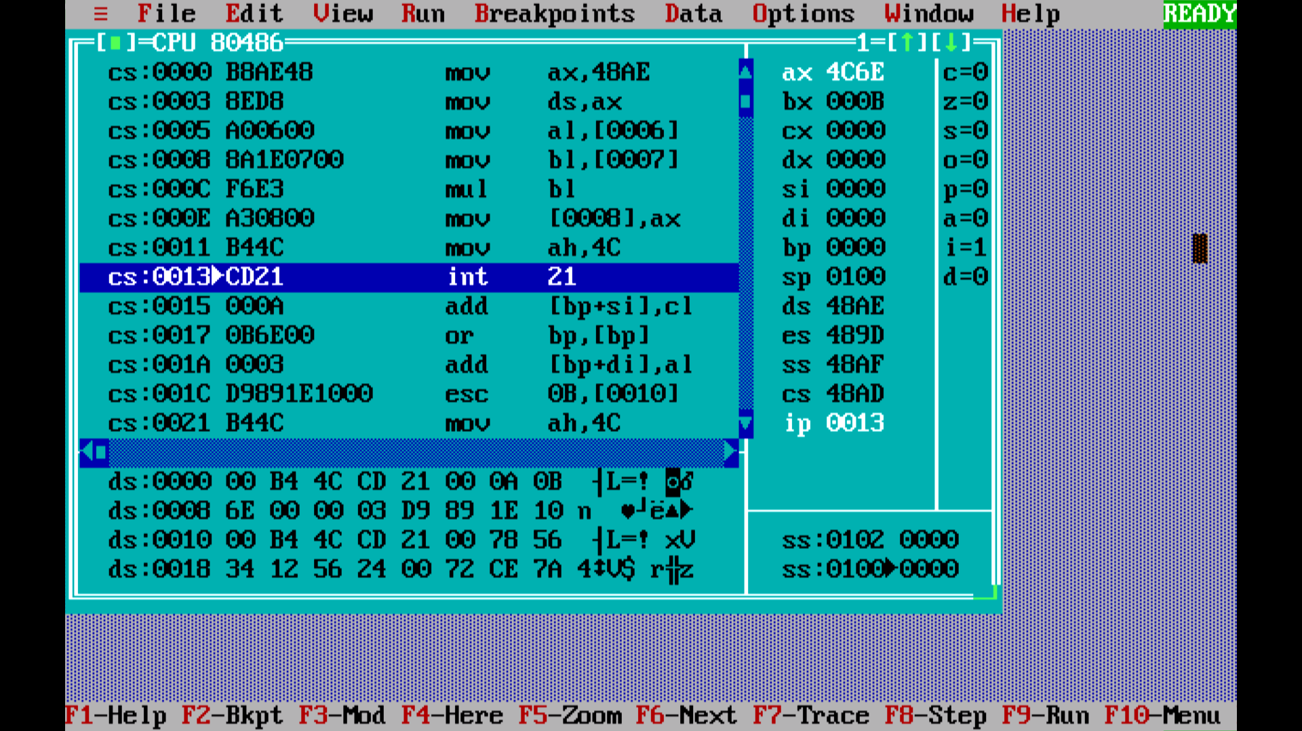

**OUTPUT :**

**Multiplication of 8 bit signed numbers**

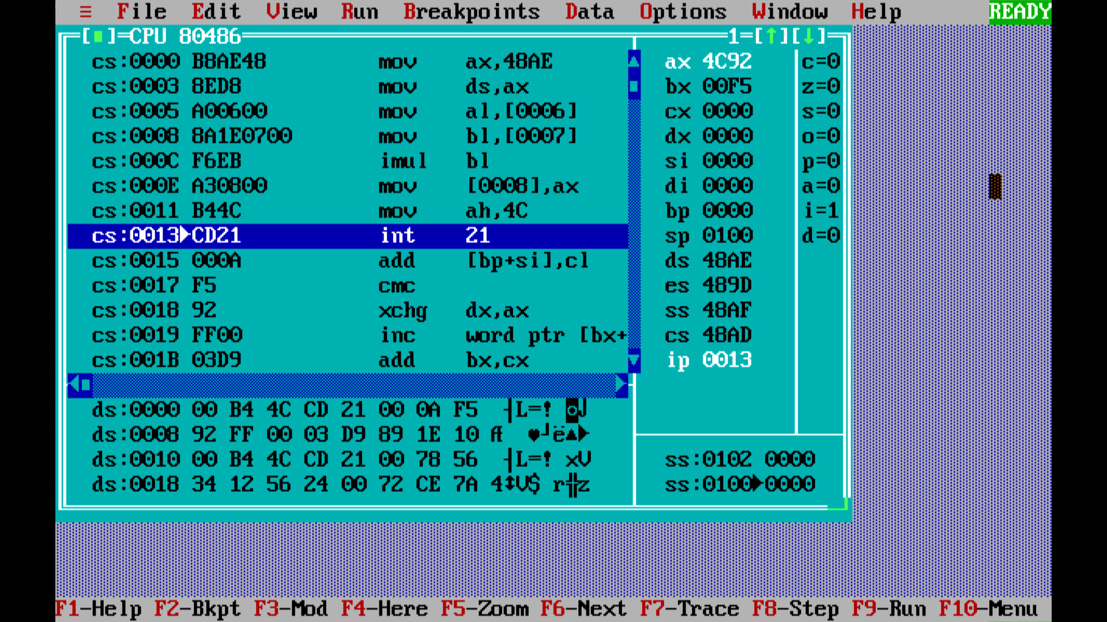

**OUTPUT :**

**Multiplication of 16 bit unsigned numbers**

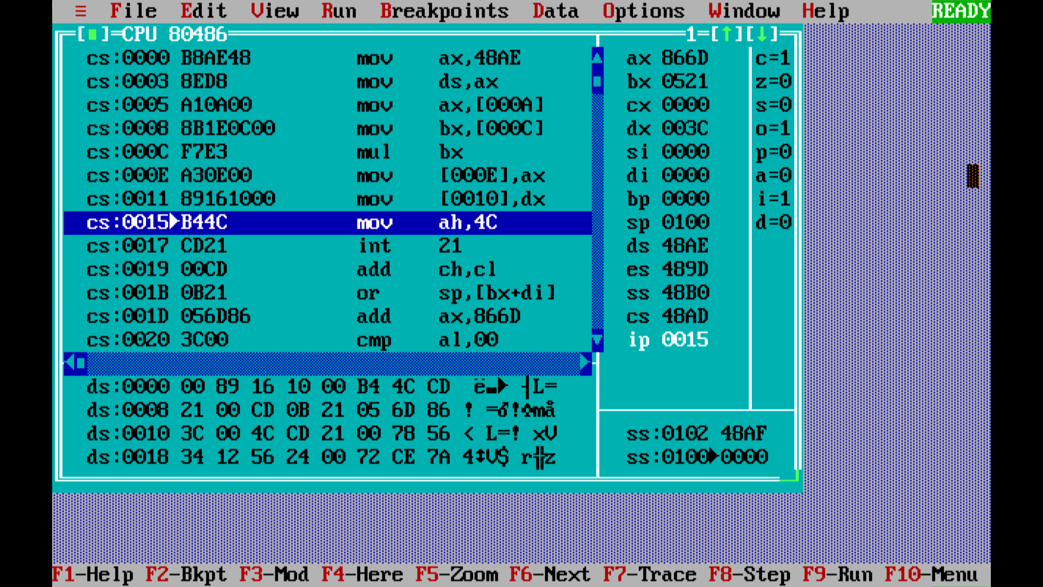

**OUTPUT :**

**Multiplication of 16 bit signed numbers**

